 

**SPARK Mid-Term Report**

**Supervisor – Dr Indrajit Ghosh**

**Intern Name – Abdul Rehman**

**Institute Name –Sant Longowal Institute of Engineering and Technology, Deemed University**

**Joining Date – 06/06/2022**

**Category – National**

**SPARK ID – SPA2212853**

**Department - Civil Engineering**

**Project Title – AI Based Software Development Kit for Driver Safety Evaluation**

**Week-wise Progress up to 4 weeks:**

**Week 1:**

**Understanding the Problem Statement** -

We aim to make a traffic sign detection model using Deep Learning methods. More formally, we aim to develop a sequence model, which takes as input the data in the form of images(.jpg format) , and outputs the right location of the traffic sign along with the direction on the traffic sign (left or right side of the driver) and the coordinates of the latitude and longitude of the traffic signs location.

**Reading Previous Work** –

Studied the previous approaches that were applied to solve the given problem, and identified their merits and drawbacks. The previous method studied was as follows –

* **Using CNN for Classification of Traffic Signs**

Convolutional Neural Network (CNN) was used to classify different Traffic Signs. The CNN model used the images from the famous German Traffic Sign Recognition Benchmark (GTSRB) as an input and returned the Sign displayed in the image in the form of numbers(class of the sign). The drawback of this method is that it cannot be used for detecting Indian Traffic signs (due to lack of dataset) . Also, the CNN model trained could only classify the images into different traffic signs, but could not detect them (create a bounding box around it), hence the actual location of the traffic sign was not known to the driver.

* **Understanding about CNN**

Read different articles and research papers to understood in deep about the different types of layers of CNN, that is the 2D Convolutional Layer, Activation Layers (RELU, Softmax), Pooling Layers (Max, Average), Batch Normalization, Fully Connected Layers, Dropout Layer. Along with this, basic Pre-Processing techniques were also read which include Splitting the Data, Encoding the data, HOG Transformation, Grayscaling.

**Week 2:**

**Literature Review**

To solve the problem statement, literature review was done by reading 25+ research papers, 15+ articles to search for the best deep-learning based models which could be adapted to solve the given problem. Along with that, different datasets were explored including the Chinese, British and the Belgium Datasets. After overviewing numerous related research papers – the following approach appeared to be the candidate’s solution for our problem –

**Using Yolo v4**

The main reason for using YOLO v4 was because of its popularity and the This class of pre-trained deep-learning model takes as input data in an image format along with their annotated labels, that is the location of the traffic sign for training. For testing, it predicts the location of the traffic sign by drawing a bounding box around the image in a rectangular form.

**Week 3:**

**Implementing the Yolo v4 model** –

1. **Generating the Dataset** –

The major challenge was to generate a generalized dataset for model training, which could detect Indian Traffic Signs. The Indian Traffic Sign Dataset (only 150 images) was taken in account from Kaggle, but due to the small size of the dataset, some additional images from the German Traffic Sign Recognition Benchmark (GTSRB) were added.

2. **Annotating the Dataset**

The next step was to label all the images manually in Yolo format for training. For this, initially [LabelImg](https://github.com/tzutalin/labelImg) tool was used, but due to some errors, a different tool named [Makesense.ai](https://www.makesense.ai) was used for the same.

3. **Making changes in the configuration file**

After this, our dataset was ready for training the yolo v4 model, now we had to make changes in the configuration file according to the dataset. Different parameters like the batch size, the number of filters, the number of subdivisions, the height and the width of the image,number of channels, step size of maximum batches and the number of classes were changed accordingly.

4. **Training the yolo v4 model**

The training was done by using the pre - trained yolo weights along with the custom dataset, different errors were being faced, after which further literature survey was resumed in search of better pre-trained models for transfer learning.

**Week 4:**

**Continued Literature Review** – Upon further searching for potential models, another possible approach was found –

**1. Google’s Inception v3 Model** – This pre-trained model by google was claimed to be the one of the best pre-trained models in deep learning. After understanding the architecture and researching about the implementation, Inception v3 model was first trained on the GTSRB using the **adam** optimizer and the loss function was selected as **categorical_crossentroy** to check the results, after adding some layers in the model, it was found out to give an training accuracy of approximately 0.9010, that is 90% accuracy after 3 epochs as shown below:

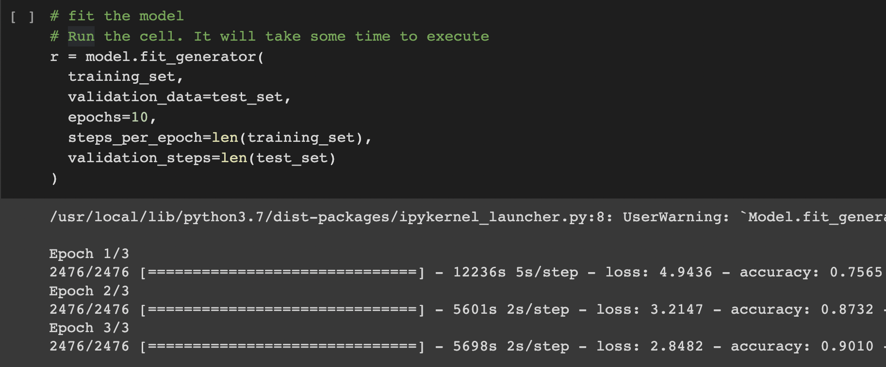

**Observations and further work**

The main objective is to tackle the errors faced in the YOLO v4 model, and start its training as soon as possible. After the training of the YOLO v4 model, testing of the model can be done on Indian roads. Parallely keep on Modifying the current dataset and adding real life to get the best results. The Testing of the Inception v3 model should be done and compared with the expected results. The further task will be to detect the location of the Traffic Sign(Left or Right side of the driver). Along with this, the latitude and longitude of the Traffic Signs should be captured from the test image.